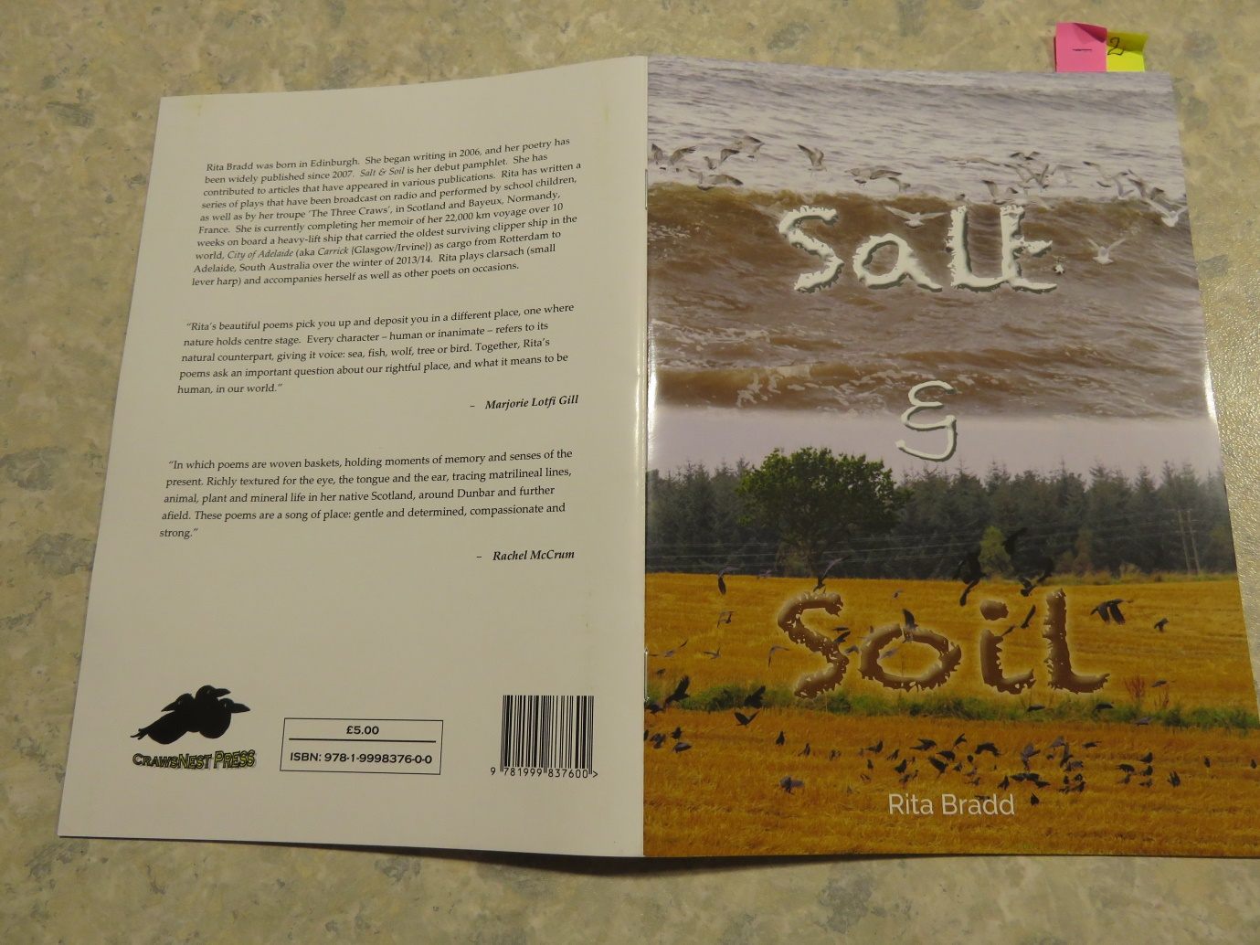

**L A U N C H**

Thursday 26 October

in HECLA Gallery

Cockenzie House & Gardens

East Lothian

7 for 7.30 pm

Refreshments will be available